DRAWING AND PAINTING COMPETITION
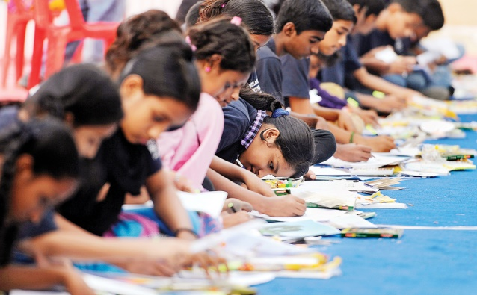 | Sunday, NOV 15th, 2015.  10.30 AM  Hotel Arihant,  Kachiguda Station Road,  Opp. Bank of India,  Hyderabad.

First Category - Below 10 years
Themes: | - Nature
- Telugu Festivals
Free Entry
Second Category - 10 to 18 years
Themes: | - Impact of TV and Internet in daily life
 | - Traffic issues
 | - Humanity
Third Category - Above 18 years
Themes: | - Education in India
 | - Agriculture
 | - Pollution in India

- The contest is open for all ages. The participant can choose any one of the above themes as per their age category.
- Each category has three cash prizes (Winner, Runner and Third place), and 10 Excellency awards from all categories. Total 19 prizes.
- Acceptable artwork:
Paintings – including acrylics and watercolor.
Drawings – including pastels, colored pencil, pencil, charcoal, ink and markers.
- Bring your own pencils, paints, erasers and all other needs. We will provide paper.
- The candidates who cannot attend the event personally, can send their drawing/painting in mail to the following address:
Aahlada, 1-2-275/1/3, Aravind Nagar Colony, Domalguda, Hyderabad – 500029.
- The drawings/paintings sent by mail should be at least A3 size or bigger, and need to receive by Nov 9th, 2015. Along with their drawing/painting, we need to get the electronic copy (CD/DVD/Thumb drive) of the video when the candidate is drawing. Full video is required. Please send the complete details of the artist including name, address, age and phone number.
FOR MORE INFO, CALL AAHLADA - 8886034559, OR CHECK AAHLADA.COM

