TELUGU/HINDI SPELLING COMPETITION

 | Nov 13th, 2016.  Sunday, 9.30AM to 12.30PM.  AAHLADA,  36 T.I.E, GATE NO.1,  Behind Andhra Bank,  Balanagar, Hyderabad.  8886034559,Aahlada.com | 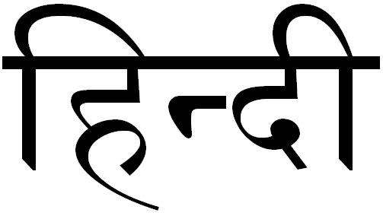

Guidelines:
- It is a Spelling Bee competition in Telugu and Hindi languages.
- Unlike normal Spelling Bee format this is a word-writing contest. The word will be announced and contestant needs to write it on provided paper.
- Once all the words are over, the papers will be collected from all participants.
- Top 2 Scorers from each age category in both languages will be awarded Winner and Runner prizes. So total 24 prizes.
- The competition will be held for one language after other for all age categories simultaneously in different rooms.
- The age categories are:

    - Sub Juniors I - Up to 7 Years (up to 2nd grade)
    - Sub Juniors II – 8 to 9 Years (3rd and 4th grade)
    - Sub Juniors III – 10 to 11 Years (5rd and 6th grade)
    - Juniors I - 12 to 13 Years (7th and 8th grade)
    - Juniors II - 14 to 15 Years (9th and 10th grade)
    - Seniors – Above 15 Years (from Inter onwards)
- Enrollment fee for Sub juniors is ₹100/- , and ₹150/- for Juniors & Seniors.
- Winners will get medals and prizes, and all participants will get certificates.
- A special category is included for slow learners (special assistance needed kids). Please encourage them to join us.

FOR MORE INFO, CALL: AAHLADA ORGANIZATION, 8886034559 or 9490417448. WWW.AAHLADA.COM

