ENGLISH/TELUGU
HANDWRITING COMPETITION
 | October 23rd, 2016.  Sunday, 9.30AM to 12.30PM.  AAHLADA,  36 T.I.E, GATE NO.1,  Behind Andhra Bank,  Balanagar, Hyderabad.  8886034559,Aahlada.com | 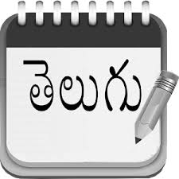
Guidelines:
- It is a Hand writing competition in English and Telugu languages.
- Contestants can participate in one or both languages.
- We provide a copy of printed matter as per their age category and a blank paper. Participants have to copy the matter on a blank sheet from printed matter within 20 minutes.
- A group of experienced judges will make the judgment based on speed, spellings, legibility, neatness, font formation and uniformity of fonts, spacing between letters and words, pen/pencil strokes and their angle, and presentability.
- Top 2 Scorers from each age category in both languages will be awarded Winner and Runner prizes. So total 24 prizes.
- The competition will be held for one language after other for all age categories simultaneously in different rooms.
- The age categories are:

    - Sub Juniors I - Up to 7 Years (up to 2nd grade)
    - Sub Juniors II – 8 to 9 Years (3rd and 4th grade)
    - Sub Juniors III – 10 to 11 Years (5rd and 6th grade)
    - Juniors I - 12 to 13 Years (7th and 8th grade)
    - Juniors II - 14 to 15 Years (9th and 10th grade)
    - Seniors – Above 15 Years (from Inter onwards)
- Enrollment fee for Sub juniors is ₹100/- , and ₹150/- for Juniors & Seniors.
- Winners will get medals and prizes, and all participants will get certificates.
- A special category is included for slow learners (special assistance needed kids). Please encourage them to join us.

FOR MORE INFO, CALL: AAHLADA ORGANIZATION, 8886034559 or 9490417448. WWW.AAHLADA.COM

