MUSICAL INSTRUMENTS COMPETITION
VENUE: 36 T.I.E, Gate No.1,
Behind Andhra Bank Building,
Balanagar, Hyderabad.
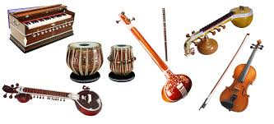 | Sunday, Nov 20th,2016  -----------  9 AM – 1 PM  For Sub Junior Category  ------------  1.30 PM – 4.30 PM  For Junior and Senior Categories

Guidelines:
- It is a solo musical instruments playing competition.
- Contestants will be judged against their peers in respected age category.
- The age categories are:
- Sub Juniors - Up to 10 Years (up to 5th grade)
- Juniors I - 11 to 15 Years (from 6th grade to 10th grade)
- Seniors – Above 15 Years (from Inter onwards)
- Any type of instruments (Violin, Keyboard, Veena, Drums, Flute, Guitar, Tabla, Mridangam, Sitar, etc.) are allowed.
- Time limit is 7 minutes.
- Except performer’s instrument, and shruti box no other supporting instruments are allowed.
- Enrollment fee for Sub juniors is ₹100/- , and ₹150/- for Juniors & Seniors.
- Each category will have four prizes: Winner, Runner, Third Prize and Consolation. So total 12 prizes.
- Winners will get trophy/medal and prizes, and all participants will get certificates.
- A special category is included for slow learners (special assistance needed kids). Please encourage them to join us.

FOR MORE INFO, CALL: AAHLADA ORGANIZATION, 8886034559 or 9490417448. WWW.AAHLADA.COM

