MUSIC COMPETITION
Free Entry
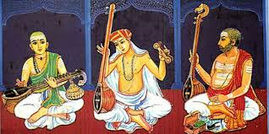 | Jan 24th, 2015.  Sunday, 9 AM  Aahlada Organization,  1-2-275/1/3, Domalguda,  Hyderabad.  8886034559,Aahlada.com

Category I | Category II | Category III
Ramadasu Keerthanas | Light Music | Patriotic Songs (Group)
Annamacharya Keerthanas | Folk Songs

- The contest will be conducted for solo performance and group performance.

- For Solo performance, the participant needs to perform any one of the keerthana from
Category I, and one song from Category II. Both together need to be completed within 6 minutes.
- The age groups for solo performance are: Below 10 years, 11 to 16 years, and above 16 years. Each age group has three prizes (Winner, Runner and Third Place)
- For group (min 4, max 6) performance, participants sing one patriotic song, not more than for 4 minutes. The group participants can be combination of any age group. Group performance also has three prizes (Winner, Runner and Third place)
- There are 10 Excellency awards from all age groups. Total 22 Prizes.

- No orchestra or Karaoke allowed, and participants need to carry their own shruti box if needed.
- No Film songs allowed.

